

prog6212 assignment

PART 1



By Josiah ethan vasa ramadu

student number: st10342895

The PROG6212 assignment part 1 needed me to build a prototype for a contract monthly claim system. This included: clear and concise documentation; a unified modeling language (UML) class diagram; a project plan in the form of a ghantt chart; and the GUI for the claim system.

The whole point of the system, is for lecturers to claim from the work they have done, and for the program coordinators and academic managers to verify the claims and then approving or rejecting them. The lecturers can fill out the information and upload supporting documents that are needed.

I have created the design for my contract monthly claim system. I kept the whole design simple, as the information is what the users really need most from the system. Having pictures everywhere and the background being very colorful will be very distracting to the user. I made the background a light brown color (#ddaf55) for all pages throughout the system. Text is black in color. Two other colors are used on the ‘approve’ and ‘reject’ buttons on the management dashboard. The ‘approve’ button is in green, and the ‘reject’ button is in red.

Log-In page:

The log in page features a label at the top (Edu-Claims) which is the name of the system, 2 textboxes, a link label, and a button. The first text box is to enter the users ID, and the second textbox is to enter the user’s password. I have a link label which is labeled: “Forgot password?” that will take the user through steps to create a new password. The button will verify if the user’s credentials is correct, then either let them into the main claims window or display an error message.

Claims page:

The claims page features 9 labels, 7 textboxes, 3 buttons, and a rich textbox. The user will enter their ID, program code, module code, submission date, hours worked, salary rate, and total. The user can also upload any supporting documents by clicking the button at the bottom left (Upload documents). Once the user clicks on the Submit button, a summary of what the user entered will be displayed in the rich textbox. The user can also view their claim statuses by clicking the button on the top right corner (View claim statuses).

Verify claims page:

This page features a data grid view, and two buttons (Approve & Reject). The data grid view will display all claims and their relevant information which is waiting for verification from the program coordinator or the academic manager.

Database structure:

The database will have 6 tables within it: Lecturer; Claims; Program coordinator; Academic Manager; Program; & Module.

Assumptions:

* Doesn’t allow external users
* Works on most of the leading operating systems
* Lecturers are only allowed to make claims
* Lecturers cant view other lecturers information
* Program coordinator can’t change user details

Constraints:

* The system must validate all claim inputs, such as ensuring that hours worked are within a reasonable range and documents are in the correct format.
* Must include secure login and encrypted data storage.

2. **UML CLASS DIAGRAM:**

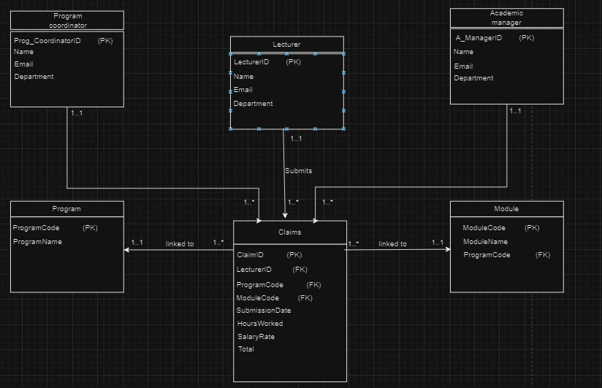

3. **Project Plan:**

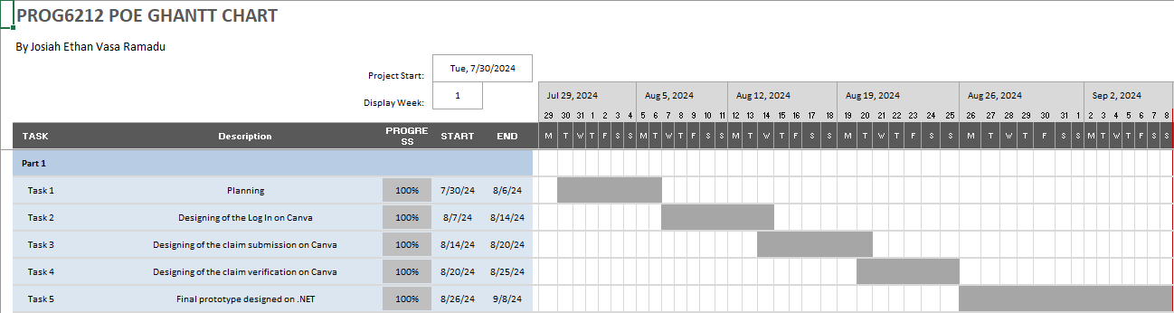

4. GUI:

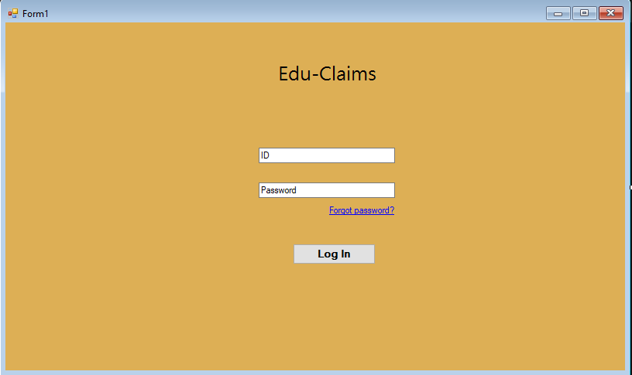

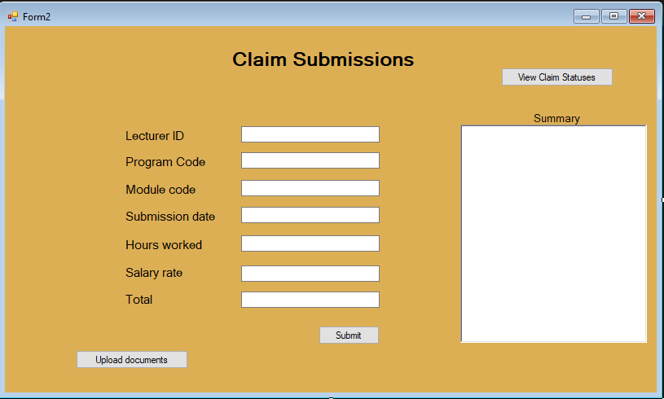

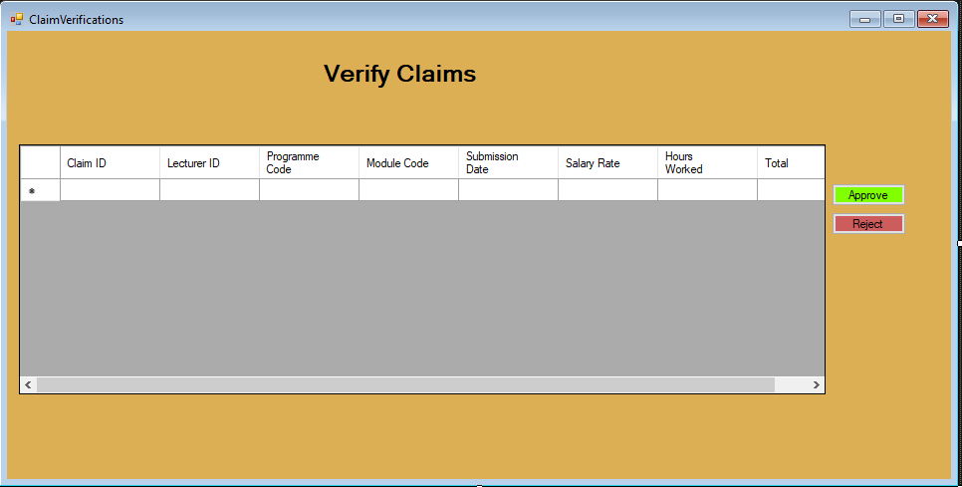

**References:**

* Draw.io
* Rani, Bhumika. “Unified Modeling Language (UML) | Class Diagrams - GeeksforGeeks.” *GeeksforGeeks*, 30 Aug. 2018, www.geeksforgeeks.org/unified-modeling-language-uml-class-diagrams/. Accessed 1 Sept. 2024.
* dotnet-bot. “RichTextBox Class (System.Windows.Forms).” *Microsoft.com*, 2024, learn.microsoft.com/en-us/dotnet/api/system.windows.forms.richtextbox?view=windowsdesktop-8.0. Accessed 2 Sept. 2024.